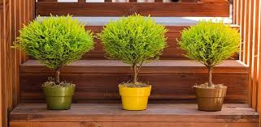

Scientific name: Cupressus macrocarpa

Light:

The tree requires a good amount of light. Outdoors, it should be planted in full sun to partial shade. Indoors, it needs five to six hours of indirect sunlight or morning sun. The hot direct afternoon sun in a west-facing window can be detrimental to the vibrant foliage.

SOIL:

Planting this tree in soil that is too rich invites trouble. The lemon cypress is adapted to grow in poor, sandy, well-draining soils that are low in organics and not very fertile

WATER:As an outdoor shrub or tree, once established, the lemon cypress needs little supplemental watering. To allow the plant to establish itself, water once a week during the first season.If kept as a houseplant, give it a thorough deep watering weekly, ensuring the soil is never too dry.

### Temperature and Humidity:

A lemon cypress prefers cool, moist climates. Temperatures above 80 degrees F in dry areas will tax the plant, while temperatures lower than 20 degrees F may cause tree damage or death.When used as a houseplant, the lemon cypress needs to be kept in a place that has sufficient humidity.

### Fertilizer:

### Fertilizing this shrub is not suggested. The lemon cypress is adapted to thrive in poor, infertile soil conditions.